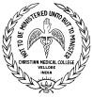
CMC EQAS - TRANSFUSION MODULE

Date: 15th December 2025
Dear Colleague,
Sub: CMC EQAS (Transfusion Module) Registration for 2026

Thank you for your interest in the EQAS program for Transfusion medicine. Kindly use the following link to download the documents required to renew your subscription for 2026. The following documents & forms are available at http://www.cmceqas.org/
- Covering Letter
- Manual for the program
- Registration form for Blood Banks
- Registration form for Laboratories
- Program Plan and pricing details form
- Methodology Survey form- IH
- Methodology Survey form - BB
- IH Result entry form

Registration forms:
For new participants, filling out the Registration and Methodology survey forms is mandatory. We require your details for further correspondence.
PIN Number: You will be allocated a 4-digit PIN Number upon receipt of confirmation of your registration and payment. Please ensure that you retain this safely and include it wherever relevant. In all your correspondence, please indicate the four-digit PIN number. The PIN is the Participant Identification number starting with TXXXX.
For participants renewing the subscription, you will retain the same PIN. Existing Participants: Please update your profile details online using your member login credentials. The renewal of a subscription will be opened on January 1st, 2026. An online payment facility is activated for existing participants.

Result entry forms:
The result entry is entirely online. Hard copies of results sent by courier or post will not be accepted. You may enter results from your Member Area, accessible from the website www.cmceqas.org. On the home page, click ‘Transfusion Members Area,’ a red link. It will direct you to the member login page.

Subscription Fees:
Please see the Program Plan and pricing document for subscription for 2026 for three surveys. For new participants, payment can be made as a Demand draft payable at Vellore favoring: “The Treasurer, CMC Vellore Association.” IMPORTANT INFORMATION:
- Registrations are open till 31st of January 2026.

Inform us immediately if there is a change in the name of the Doctor / Pathologist in charge of the laboratory, address, Land number, and mobile number.

Yours sincerely
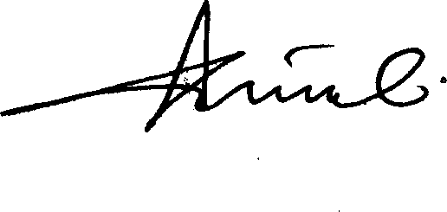
Prof. Alok Srivastava Chairperson

Effective:  15/12/2021 | Version 3.0 | Transf_ Cover letter | 1/1

